Candidate PSY is here to LOWER CHILDCARE COSTS
Did you know that the cost of childcare has increased almost every year since 2008? Families are struggling to afford these costs, and it’s eating away at their paychecks.
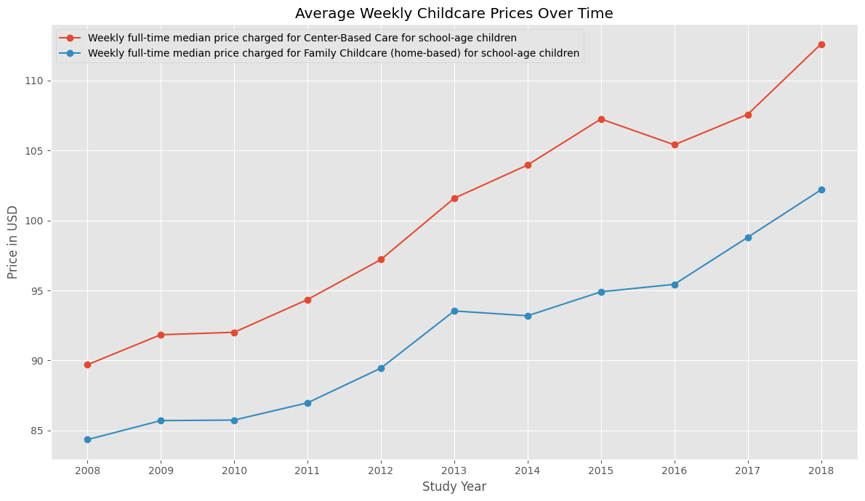
Between 2008 and 2018, the earnings increases failed to keep up with the growth of childcare costs. Both male and female wages aren’t growing to keep pace with childcare costs. Candidate PSY will spearhead legislation to bring down childcare costs and grow the economy.
